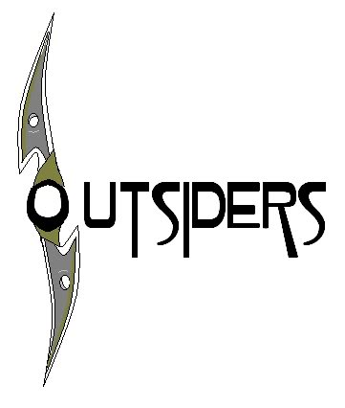
The Outsiders – Chapter 2 Questions
*Answer all of the questions below. Remember: all answers should be in full sentences and contain direct references to the novel. Using direct examples with page numbers creates a solid argument.
*Put the answers to these questions on a separate sheet of paper. When you are finished be sure to staple your answers to the back of this sheet, write you name in the top-right corner and hand it in to Mr. E.

1. Who is the fuzz? (p. 20)
2. Are the names Ponyboy and Sodapop nicknames? Explain.
3. Who are Cherry and Marcia?
4. Why doesn't Ponyboy like referring to Sodapop as a dropout?
5. What is Ponyboy comparing Two-Bit to when he calls him a "chessy cat" on page 27? What figure of speech is this besides a simile?
6. What is "a weed" slang for in 1967?
7. Why does Dally look sick now (p. 33)?

