*Put the answers to these questions on a separate piece of paper (you will need room for full answers)
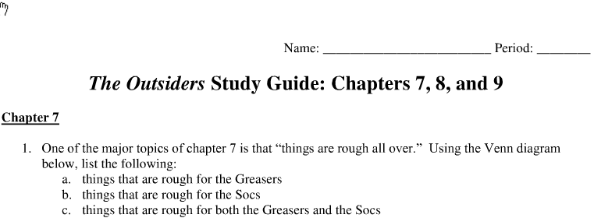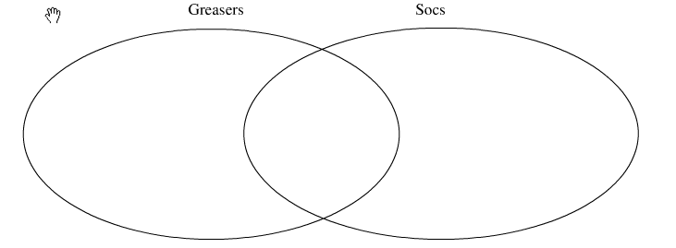

[Type a quote from the document or the summary of an interesting point. You can position the text box anywhere in the document. Use the Text Box Tools tab to change the formatting of the pull quote text box.]
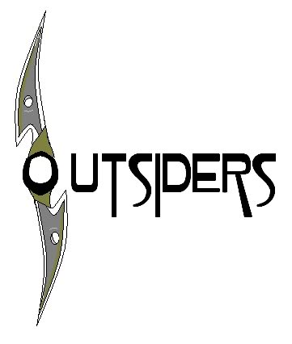
The Outsiders – Chapter 7 Questions
*Answer all of the questions below. Remember: all answers should be in full sentences and contain direct references to the novel. Using direct examples with page numbers creates a solid argument.
*Put the answers to these questions on a separate sheet of paper. When you are finished be sure to staple your answers to the back of this sheet, write you name in the top-right corner and hand it in to Mr. E.
1. Explain what Pony means when he says Soda "reminds me of a colt" on p. 101.
2. What condition is Johnny in after the fire?
3. Why would being crippled be worse for Johnny than someone else?
4. "Maybe people are younger when they are asleep" (p.104). what do you think about this comment?
5. What is a juvenile delinquent (p. 107)? Find a definition on the internet, in a dictionary, or create your own based on your own knowledge.
6. Why would Two-Bit think Johnny, Dally, and Pony were heroes all along; before they saved the kids?
7. What was Bob's 'real' problem, according to Randy (p.116)?
8. Why did Pony think it was better to see socs as "just guys" on p. 118? What do you think he means by this?

