http://weeklyworldnews.com/headlines/25951/michael-jackson-spotted-on-the-moon/

MICHAEL JACKSON SPOTTED – ON THE MOON!
Posted on Tuesday, December 14th, 2010
By J.B. Smitts
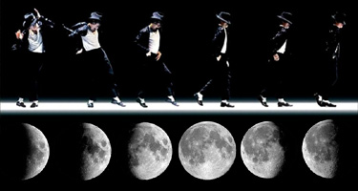
CAPE CANAVERAL, FL – Photos from International Space Station reveal undeniable evidence that Michael is not dead – he’s living on the moon!
Last week, crew members aboard the space station radioed Mission Control after they spotted what they described as a “strange, effeminate man-child in a sequin jacket” doing leg kicks on the surface of the moon.
“They wanted to know if they could take pictures of thing,” said NASA engineer Mark Mallowry. “We thought it was probably just some space dust, so we told them to take as many pictures as they wanted.”
But when the photos arrived at NASA headquarters in Houston, Texas, Mallowry and his colleagues were shocked at what they saw.
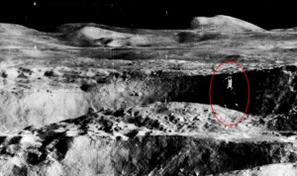
“I could not believe what I was looking at,” Mallowry said. “There, right in front of my eyes, was Michael Jackson! On the surface of the moon!”
The photos depict an aged Michael Jackson doing the moonwalk outside of a lunar space module. Also visible in the photograph is Michael’s chimpanzee friend, Bubbles.
“This is a mind-blowing discovery,” said Mark Housman, Director of NASA’s Lunar Imaging Department. “I had a hunch that Michael Jackson wasn’t really dead, and it makes sense that he’s living on the moon. He was just too weird for this planet.”
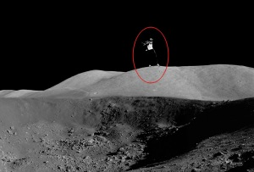
This startling evidence refutes claims long-held views that the King of Pop died of a drug overdose in 2009, or that he is living on a secluded island with Elvis, Tupac, and Biggie Smalls.
Some of Michael’s friends and family were overjoyed upon hearing the news.
“I knew the MJ wasn’t dead,” said Chris Tucker, an actor and lifelong friend of Michael Jackson. “It makes me so happy knowing that my best buddy is up there on the moon, just doing what he does best where no one can bother him.”
Others were convinced that the pictures were hoax, released by NASA as a promotional stunt for Jackson’s latest album, Michael, which was produced and edited by Quincy Jones.
But Jones was quick to defend himself against the accusations.
“Michael and I have been working on this album for a long time,” said Jones in a phone interview. “He would send me tracks from his house on the moon, and I would edit them here on earth.”
“And believe me,” he added. “I am not making this up. After all, this is Michael Jackson we’re talking about – he’s done much, much weirder.”

